

# **Zomato Data Analysis Using Python**

By Hemanand S

# Project Objective

We had the dataset where we have got information about online orders based on restaurant. So we need to analyze the people opinion on different parameters

To address the analysis, we need to respond to the subsequent inquiries:

1. Do a greater number of restaurants provide online delivery as opposed to offline services?
2. Which types of restaurants are the most favoured by the general public?
3. What price range is preferred by couples for their dinner at restaurants?

## Heading 2

We had used python code with data analysis, visualization library such as seaborn, pandas, Matplotlib and NumPy to analysis the data.  
  
Below are the sample results:

Pic:1 Count of restaurant and maximum count 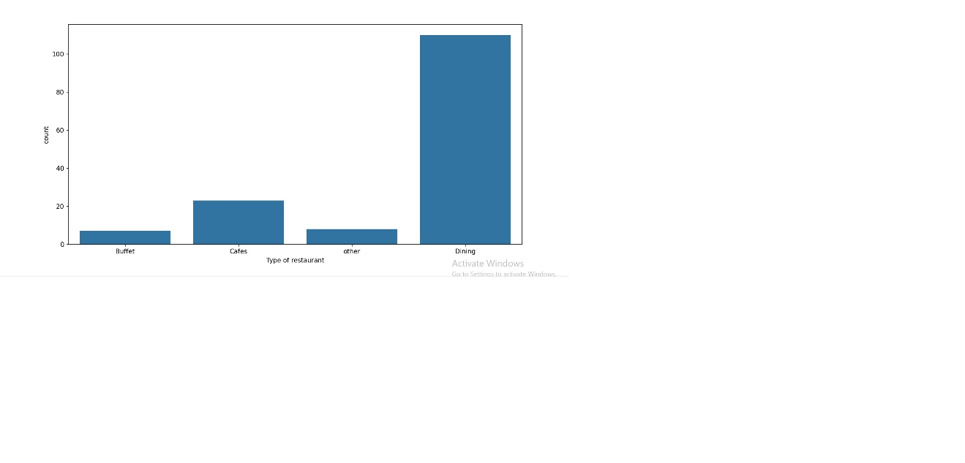

Pic 2: Votes by type of restaundant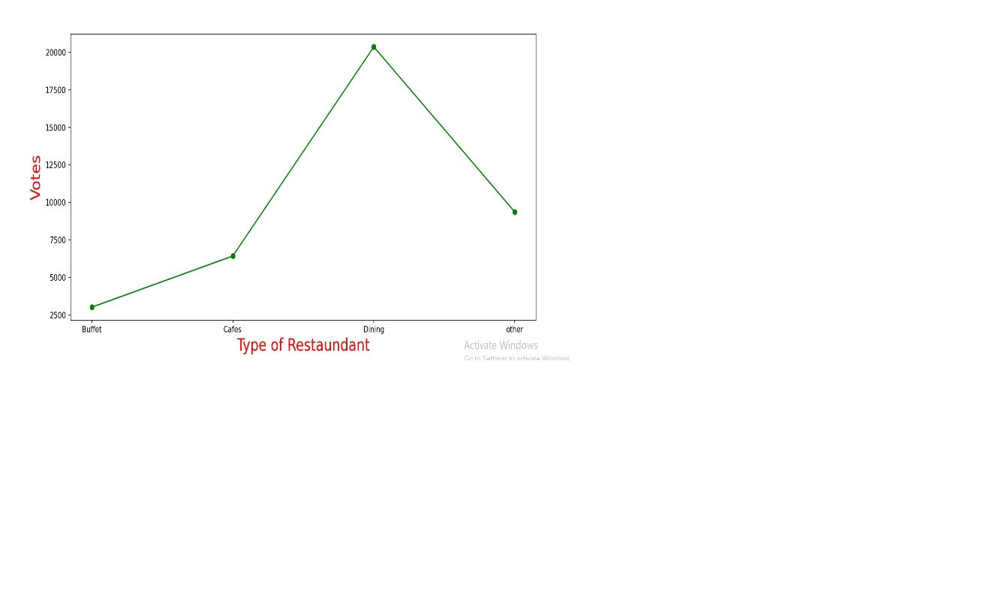

Pic 3: Type of restaudant and orders type count

